TECTONIC GEOMORPHOLOGY ANALYSIS OF THE EAST LEMBANG FAULT SYSTEM IN THE UJUNG BERUNG AND JATINANGOR AREA, WEST JAVA, INDONESIA

Murni Sulastri^{1,2}, Imam A. Sadisun³, Nana Sulaksana⁴, Sukrisyanti⁵,
Pradnya Paramarta Raditya Rendra⁴, Sri Wahyuni⁴
¹ Geological Technology Study Program, Mining Energy Polytechnic Bandung, Bandung, Indonesia
² Doctoral Candidate in Geological Engineering, Faculty of Earth Sciences and Technology,
Bandung Institute of Technology (ITB), Indonesia
³Applied Geology Research Group, Faculty of Earth Sciences and Technology,
Bandung Institute of Technology (ITB), Indonesia
⁴ Faculty of Geological Engineering, Universitas Padjadjaran, Bandung, Indonesia
⁵ Research Center for Geotechnology, National Research and Innovation Agency (BRIN), Bandung, Indonesia
Email : murni.saripudin26@gmail.com

KEYWORDS: Tectonic Geomorphology, Lembang Fault, Geomorphic Indication.

ABSTRACT: Lembang fault is an active fault that may trigger earthquakes and landslides in the North Bandung area. The movement of the fault is on the mainland, theLembang fult is still being debated even though an earthquake has been recorded which may have originated from this fault. The epicenter in the Cihideung area, in addition to tectonic influences, the activity of the Lembang fault is also thought to be influenced by volcanism which can affect the mechanism of fault movement. Tectonic processes play an essential role in the formation of the morphology of an area. The Lembang fault is a normal fault that was formed as a result of tectonic activity in the Neogene sge, located in the northern part of Bandung, stretching for 30 km in a west-east direction, the existence of this fault has shaped the morphology of the Lembang plains to the north and forms a hilly path trending west-east to the north. South. Tectonic geomorphology is the main factor that controls the development of landforms in active tectonic areas and have a significant influence on the natural features of mountains and watersheds which are located east of the Lembang fault, Cikapundung, and Cikeruh. Trending northwest-southeast geomorphic indication analysis is used to study tectonic activity in the study area in the form of basin shape (Bs), watersheds gradient index (SL), drainage basin asymmetry (Af), mountain face sinuosity (SMF) and valley floor width to valley height ratio (Vf). These geomorphic indication variables are combined to produce degrees of relative tectonic activity in the research area which can be divided into four classes; class 1 has a very high relative tectonic activity index, class 2 has a relatively high tectonic activity index, class 3 has a relatively moderate tectonic activity index, and class 4 has a relatively low tectonic activity index, field observation data in the form of the landform and geology of the research area support these results.

INTRODUCTION
Geomorphology proves invaluable in tectonic research by aiding in the identification, comprehension, and utilization of the Earth's surface features shaped by tectonic forces. These geomorphological formations store vital information, reflecting the cumulative impact of tectonic activities spanning from thousands to the last two million years (Keller and Pinter, 1996). Analysing these geomorphic records furnishes the essential insights required to fathom the influence of tectonics in a specific area. Tectonic geomorphology is a scientific discipline that delves into the interplay between tectonic and geomorphic processes, especially in regions where the Earth's crust is actively undergoing transformations (Hugget, 2011). Tectonic processes assume a pivotal role in shaping the character of a given geographical region.
The Cikapundung watershed is situated within the upper reaches of the Cikeruh watershed and shares its border with an active regional fault known as the Lembang fault. Active faults play a central role in shaping the landscape in areas affected by tectonic forces (Sulaksana, 2017). The Lembang fault, specifically, is categorized as a normal fault that originated from tectonic activities during the Neogene period. It is located in the northern part of Bandung and stretches approximately 30 kilometers in a east-west direction. The presence of this fault has significantly influenced the topography of the Lembang plains to the north, resulting in the formation of a hilly terrain that trends from west to east and extends southward (Haryanto, 2006). To quantify the impact of tectonic activity on the area's morphology, a quantitative geomorphological analysis is being conducted to determine the index of relative tectonic activity. This assessment aims to describe how tectonic forces have shaped the landscape in this region.
The geological formations in West Java have been shaped by the collision between the Indo-Australian Plate, which subducted beneath the Eurasian Plate (Hamilton, 1979). Among the active faults in the north Bandung area, the Lembang fault is notable for its role in triggering earthquakes and landslides. The movement of this fault primarily occurs on land, although there is ongoing debate about its behavior, despite recorded earthquakes that may have originated from it. In addition to tectonic influences, the activity of the Lembang fault is believed to be influenced by volcanism, which can affect the way the fault moves (Hariyadi, 2017). The composition of the Lembang fault includes predominantly peat soil layers, and its steep slope increases the potential for landslides that could pose a threat to nearby residential areas.
The research area is included in the physiographic zone of Bandung, West Java (Van Bemmelen, 1949), mostly filled with young volcanic deposits from the surrounding volcanoes. The research area is included in the Geological Map of the Regional Sheet of Bandung Quadrangle, Java (Silitonga, 1973). The stratigraphic sequence from old to young is old undifferentiated unresolved volcanic products (Qvu), young undifferentiated unresolved volcanic products (Qyu), and lake deposits (Ql).
Several morphometric parameters are used in this analysis, including calculating the hypsometric integral (HI), assessing the outflow asymmetry factor (Af), and determining the gradient of the flow length index (SL). Previous researchers in West Java such as Supartoyo (2008) and Hidayat (2009) applied this morphometric technique in examining the Lembang fault. The main objective of this research is to assess the level of activity of the central to eastern Lembang fault system by utilizing morphometric methods combined with geomorphological and morphotectonic data. A thorough understanding of the active tectonics in this region will greatly improve our ability to anticipate potential earthquakes and landslides that may occur in the future. This knowledge is critical for the implementation of effective landslide disaster mitigation measures in the region (Figure 1).

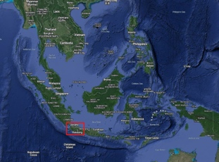
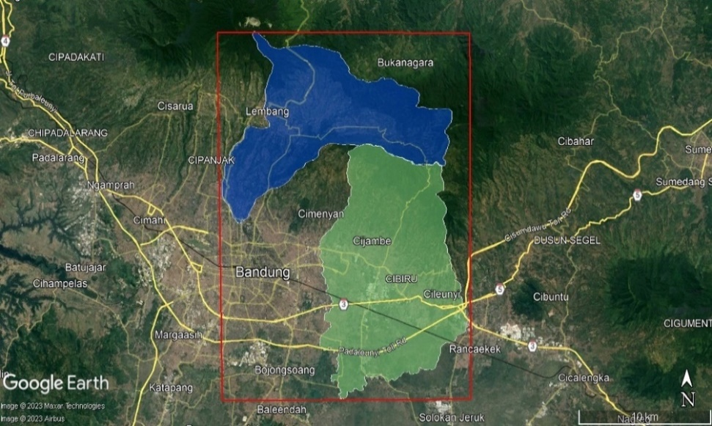
Figure 1. Map of the research area

METHOD
The research area is located in the eastern part of the Bandung basin (Figure 1). The data used in this study are geomorphological and morphotectonic data. Morphotectonic observation data are from the Geospatial Information Agency (BIG) and SRTM (Shuttle Radar Topography Mission). Morphometric analysis uses hypsometric integral (HI) calculations, basin asymmetry factor (Af), Basin Shape (Bs) and overlap to obtain activity, namely by analysis of the flow length gradient index (SL), Relative Active Tectonics Index (IATR), and is supported by geomorphological data can be observed directly in the field.
Tectonic geomorphology studies the relationship between geological structure and landform or more specifically the relationship between neotectonic structure and landform (Stewart and Hancock, 1994). To identify the Lembang Fault system, various sources of morphotectonic data, such as topographic maps, SRTM data, and aerial photographs, were examined. Using software tools like ArcGIS and Global Mapper, we analyzed these data to detect general patterns of linear features along the Lembang fault zone. This analysis aids in recognizing the Lembang fault system itself, as well as landform and other morphotectonic characteristics in the area.
Morphotectonic data is integrated to identify relative active tectonics exhibited by the Lembang fault System. Both field data and computational data are analysed in a quantitative manner to derive a tectonic geomorphological classification that accurately represents the extent of tectonic activity observed within the Lembang fault system.

RESULT AND DISCUSSION
The morphotectonic characteristics of the eastern Bandung region were examined by analysing the SRTM map data and topographic features, revealing the presence of the Lembang fault within the research area. By combining these data sets, numerous linear features oriented in the northwest-southeast and north-south directions were identified, allowing for the delineation of these lineaments between the mountain front and the poid mount junction plains. The morphotectonic map illustrates that the topography in the study area closely mirrors the shape of the hills, extending predominantly in an east-west direction.
The analysis of lineaments reveals a predominant pattern in the vicinity of the eastern Lembang fault zone, characterized by a prevalence of lineaments oriented in the northwest-southeast to north-south direction. This analysis is based on a comprehensive examination of all lineament data, and it effectively highlights the presence of geological structural features like faults, folds, and layering. The confirmation of geological structures in the eastern Lembang fault area is supported by field data, including observations of joints, fault scarps, and rock offsets. These geological structures can be synthesized from the findings of various previous researchers.
Morphometry
- Watershed

The morphometric analysis involved identifying the rock composition within each watershed and subsequently computing various morphometric parameters. These calculations were based on digital topographic map data and encompassed parameters such as drainage basin asymmetry factors, stream gradient index and watershed basin shape. The morphometric parameters were derived from watersheds situated in the eastern part of the Lembang fault, specifically within the Cikapundung and Cikeruh watersheds, which flow in a northeast-southwest direction. The order was chosen because there is a new tectonic process (neotectonic) then what will represent the geomorphic process is in the form of a 1st order watershed (tectonic process > erosion process) according to Keller and Pinter 1996; Arisco et al, 2006 and dehzorgi et al, 2010. The research area was subdivided into 13 sub-watersheds within Cikapundung, with an additional 21 sub-watersheds within Cikeruh, all watersheds varying trends, predominantly aligning in a northeast-southwest direction (Figure 2).

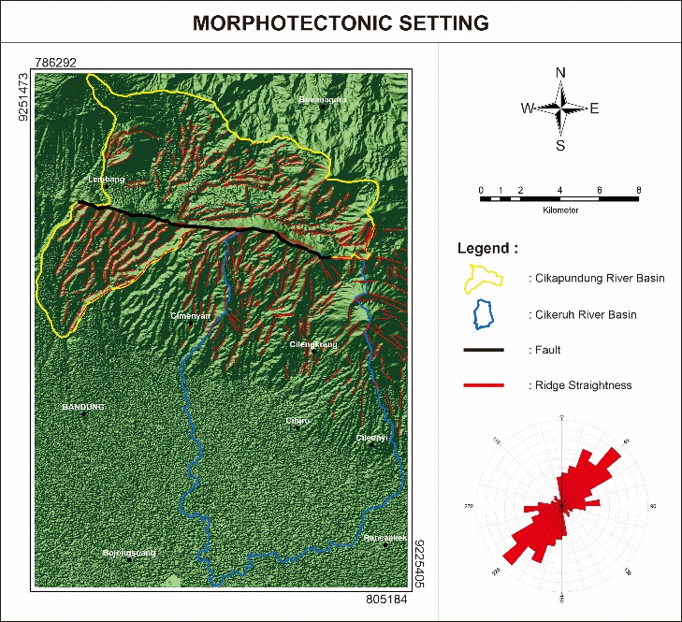
Figure 2. Morphotectonic map of the Cikapundung and Cikeruh watersheds

- Lithology

In the research area, the geological composition consisting of volcanic rocks within each sub-drainage area was assessed using information extracted from the Bandung sheet regional geological map. To determine the specific lithology of each sub-watershed, geological maps were superimposed onto 1st order watershed data, as illustrated in Figure 3. Subsequently, the extent of each lithological area was computed and organized into a table based on the outcomes of this rock composition analysis. This information was gathered to support morphotectonic and morphometric analyses. The primary lithological compositions observed in each watershed predominantly consist of volcanic formations such as tuff, sandstone, volcanic products, and lake deposits (Figure 3).

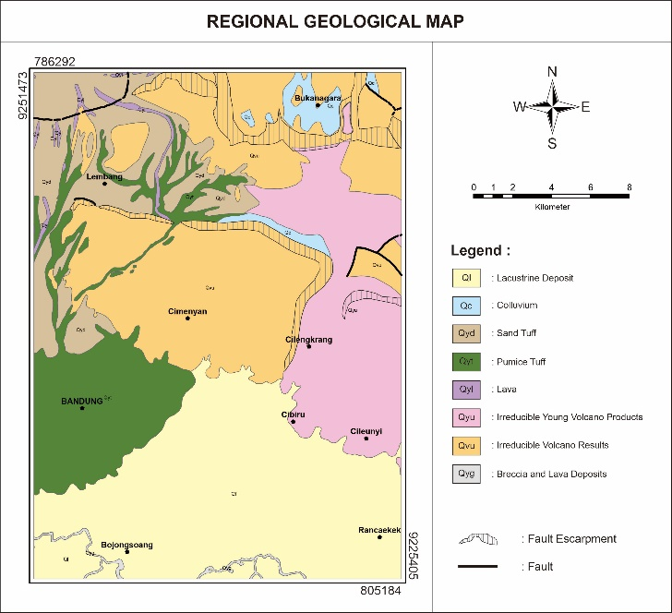
Figure 3. Regional geological map of the research area
(Bandung Quadrangel; modification by Sulastri; 2023)

- Hypsometric Integral (HI)

According to Keller and Pinter, (1996), hypsometric integral describe the distribution of elevation across an area called a drainage basin or sub-basin in an area. This index can define the relative area under the hypsometric integral and can describe the volume of a basin that has not been eroded. Several watersheds in the research area show that the young stage, middle stage and old stage from the results of hypsometric integral measurements. The results of the calculations depicting the hypsometric integral show that in general the watersheds around the eastern Lembang fault are in the young and old stages. This young stage topography can indicate a tectonic process (Denbozorgi, 2010); if the young stage landscape is categorized into class one (1), the middle stage is categorized into class two (2), and the old stage is categorized into class three (3). The results of the HI calculation for the research area are classified into two categories, namely class (2) middle and class (3) (Figure 4).

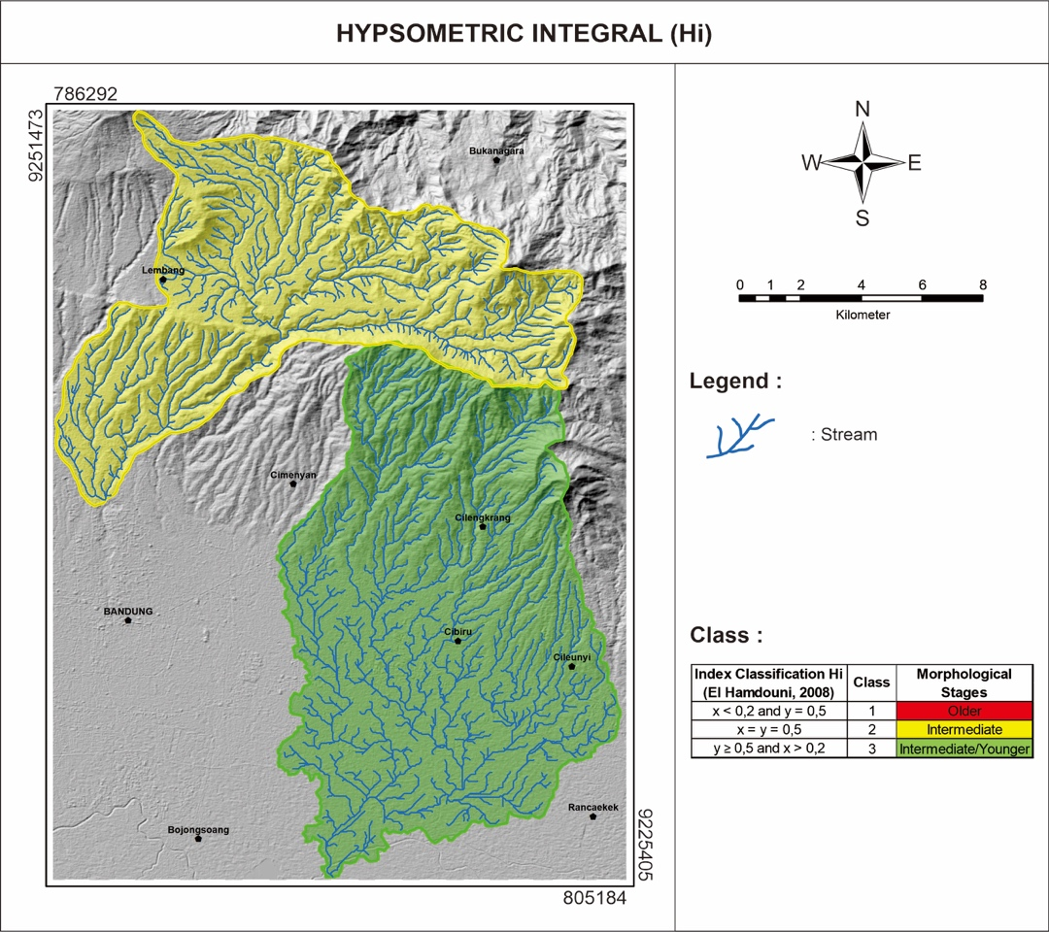

Figure 4. Hypsometric Distribution of the Research Area
- Asymmetry Factor (AF)

According to Keller and Pinter (1996), the assessment of the AF value serves as a means to appraise the tectonic gradient on a watershed scale. When the AF value approximates 50, it suggests relatively stable tectonic conditions. However, if the value falls below 50, it indicates that tectonic activity has led to uneven slopes within a specific portion of the sub-drainage area. This method is effectively used in drainage basins that are connected to the same bedrock (El-Hamdoni et al, 2007). Many researchers have previously used this method to show IATR (Relative Active Tectonics Index) values (Gentana, et al., 2018).

AF = 100 (Ar/At)......................... (1)
Explanation:
AF | : | asymmetry factor
Ar | : | the area of the basin to the right (facing downstream)
At | : | the total area of drainage basin

The results of calculating AF values in the Cikapundung and Cikeruh watersheds show that tectonic activity is high to low. AF calculations were carried out in 34 (thirty-four) sub-watersheds consisting of 13 (thirteen) Cikapudung sub-watersheds and 21 (twenty-one) Cikeruh sub-watersheds. The 1.56-79.73 km value is spread over the Cikapudung and Cikeruh watersheds. The high tectonic class in the Cikapudung watershed is in the western part of the sub-watershed (1,2) with a value range of 25.11-27.92, and the middle class is in the eastern, northern, and central parts of the CIK sub-watershed (5,10, 13) with a value range of 9.18-13.34, and the low class is in the northern, central and northeastern parts of sub- watershed (3,4,6,7,8,11,12) with a range of 1.56- 7.71.

There are 3 tectonic classes in the Cikeruh sub-watershed, high, middle and low. The high tectonic class in the Cikeruh watershed is in the northern, middle part of the sub-watershed (1,2,9,10,12,15) with a range of 14.66-75.86 km. The middle class is in the northeast, and middle of the sub-watershed (5,7,8,11,13) with a range of 37.72-60.74 km. As well as the low class is in the northeast, east, central and west parts of the sub-watershed (3,4,6,14,18,19,20,21) with a range of values of 43.13-50.84 km. According to Keller and Pinter (2002), the asymmetry factor is a method for determining the tectonic gradient in a drainage basin, both small and large scale, in a watershed, based on the description above, it shows that the Cikapundung and Cikeruh upstream have AF values in the western part, middle and south so that the watershed is controlled by active tectonics of the eastern region of the Lembang fault (Figure 5).

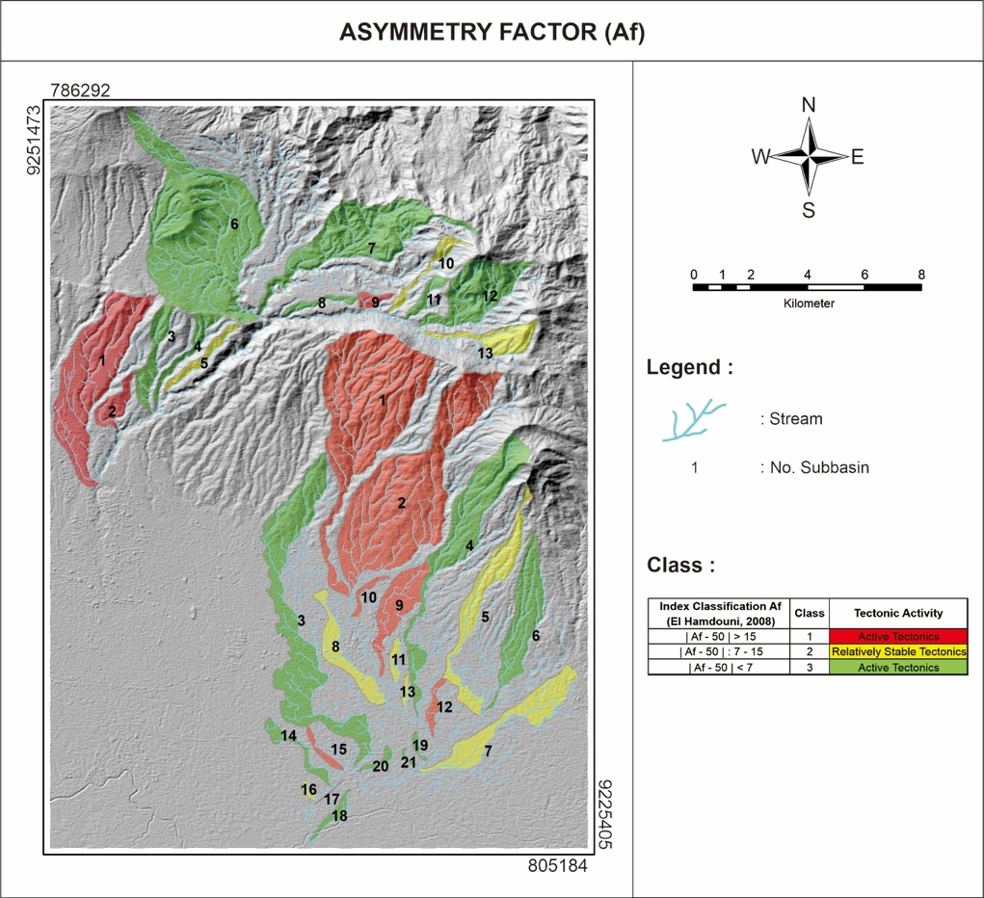
Figure 5. Asymmetry class map of the Cikapundung and Cikeruh watershed

- Basin Shape (Bs)

The basin shape describes the horizontal projection of the watershed. Watersheds that are at a young stage with active tectonics tend to have an elongated shape (Ramirez-Herrera, 1998). Basin shape can reflect the rate of active tectonics. The size of the basin shape can be explained by the comparison of length to diameter which is analysed using the following equation (Cannon, 1976 in Ramirez-Herrera, 1998):

Bs = Bl/Bw......................... (2)
Explanation:
Bs | : | basin shape
Bl | : | length of the basin
Bw | : | width of the basin

Basin shape can be calculated using DEM and classified into three classes: 1 (Bs > 3), 2 (3 > Bs > 2) and 3 (Bs < 2) refer to El Hamdouni et al. (2007). The basin shape in the research area ranges from a value of 0.32 to 3.40. Less than half of the watersheds in the research area are in class three (3) with a shape approaching a circle (Figure 6).

The calculations of Bs values within the Cikapundung and Cikeruh watersheds reveal a spectrum of tectonic activity ranging from low to high. Specifically, Bs calculations were conducted for 21 sub-watersheds within Cikapundung and 13 within Cikeruh. These sub-watersheds exhibit Bs values spanning from 1.63 to 6.71 across the Cikapundung and Cikeruh watersheds.

Within the Cikapundung watershed, the sub-watersheds in the middle portion (namely, 4, 5, and 8) exhibit active tectonic characteristics, with Bs values ranging from 4.63 to 5.41. In contrast, moderate tectonics are observed in the northern part of sub-watershed 10, where the Bs values range from 3.10 to 3.68. Inactive tectonics prevail in the western, central, and northern regions of sub-watersheds 2, 3, 4, 5, 6, 9, and 10, with Bs values ranging from 3.06. Subsequently, low tectonics are evident in the northern, eastern, southern, and western portions of sub-watersheds 1, 2, 3, 6, 7, 9, 11, 12, and 13.As for the Cikapundung watershed, active tectonic activity is observed in 10 sub-watersheds distributed across the eastern, central, south, and southwest regions, specifically sub-watersheds 3, 4, 5, 7, 8, 9, 13, 14, 18, with Bs values ranging from 3.05 to 4.61. Moderate tectonics are noted in the northeastern, eastern, and southern parts of sub-watersheds 2, 6, 10, 11, 19, 20, 16, and 17, with Bs values ranging from 2.08 to 2.75. Inactive tectonics characterize the central, northwest, and southwest areas of sub-watersheds 1, 12, 15, and 24, exhibiting Bs values ranging from 1.55 to 1.96 (Figure 6).

The basin shape index calculation outcomes exhibit high sensitivity to variations in the channel slope. Assessing this sensitivity can help in examining the connection between current tectonic activity, rock durability, and the landscape's features. The Bs index serves as a tool for identifying presently active tectonic processes, commonly known as neotectonics. Bull and McFadden (1977) asserted that regions displaying elevated Bs index values are indicative of being influenced by active tectonics. Such areas typically feature elongated ridges interspersed with valley formations. Based on the analysis of the calculation results stated that the east, south, and center of the Cikapundung and Cikeruh watersheds are controlled by active tectonics from the eastern part of the Lembang fault.

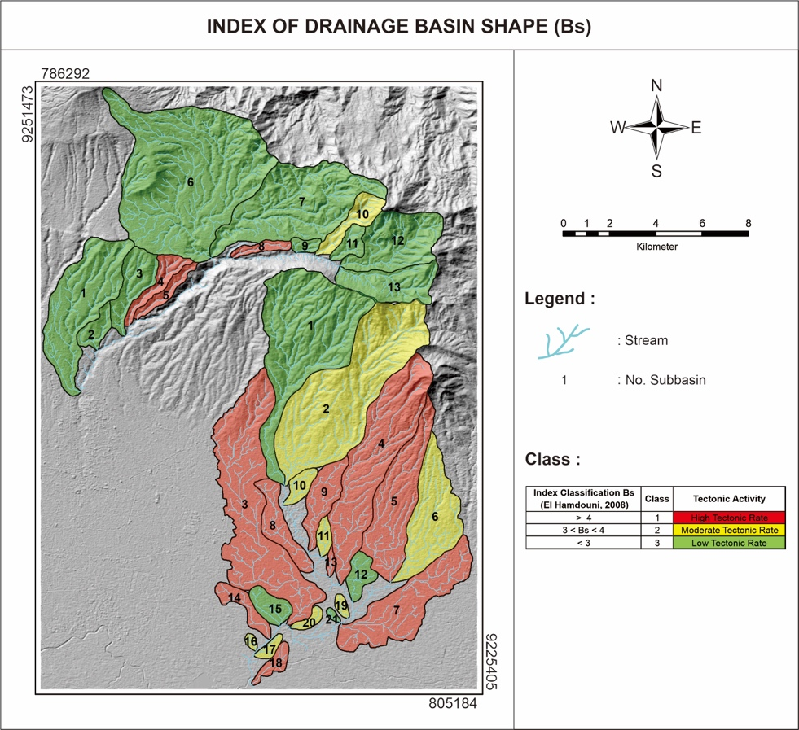
Figure 6. Map of Bs calculations in the research area

- Stream Length Gradient (SL)

Watershed that traverse rock and soil undergo distinct adjustments in their strength as they strive to attain equilibrium, resulting in the creation of a specific longitudinal profile and hydraulic geometry (Bull, 2007). Hack (cited in Dehbozorgi et al., 2010) defines the stream length gradient as a variable that exerts an influence on the environmental conditions along the longitudinal profile of a watershed, particularly in watersheds that have achieved a state of equilibrium. The stream length gradient can serve as a relative measure for assessing tectonic activity. A high stream length gradient value indicates the potential presence of tectonic activity. The stream length gradient (SL) is computed from topographic maps using the following equation:

SL = (ΔH / ΔL) x L......................... (3)
Explanation:
ΔH | : | the difference in altitude between two points in the watercourse
ΔL | : | the length of this stretch
L | : | the total length of the channel

The results obtained from computing the overall stream length gradient value within the Cikapundung and Cikeruh watersheds reveal a diverse range of watershed relief textures, from medium to very low classifications. These variations in stream length gradient values are indicative of differing levels of uplift in the research area. The stream length gradient calculations were conducted across a total of 34 sub-watersheds, comprising 13 in the Cikapundung watershed and 21 in the Cikeruh watershed.

In the context of the Cikapundung watershed, the classification of stream length gradient values reveals the presence of 3 sub-watersheds characterized by moderately high levels of uplift, with stream length gradient values falling within the range of 318.19 to 377.23. These sub-watersheds are distributed predominantly in the northern and western regions, specifically in sub-watersheds 6, 7, and 10. Conversely, 10 sub-watersheds in the Cikapundung watershed exhibit low uplift levels, encompassing stream length gradient values ranging from 41.70 to 247.35. These sub-watersheds are identified as 1, 2, 3, 4, 5, 8, 9, 11, 12, and 13. As for the Cikeruh watershed, all sub-watersheds within it share a common characteristic of low tectonic activity, with stream length gradient values ranging from 0.94 to 271.72 (Figure 7).

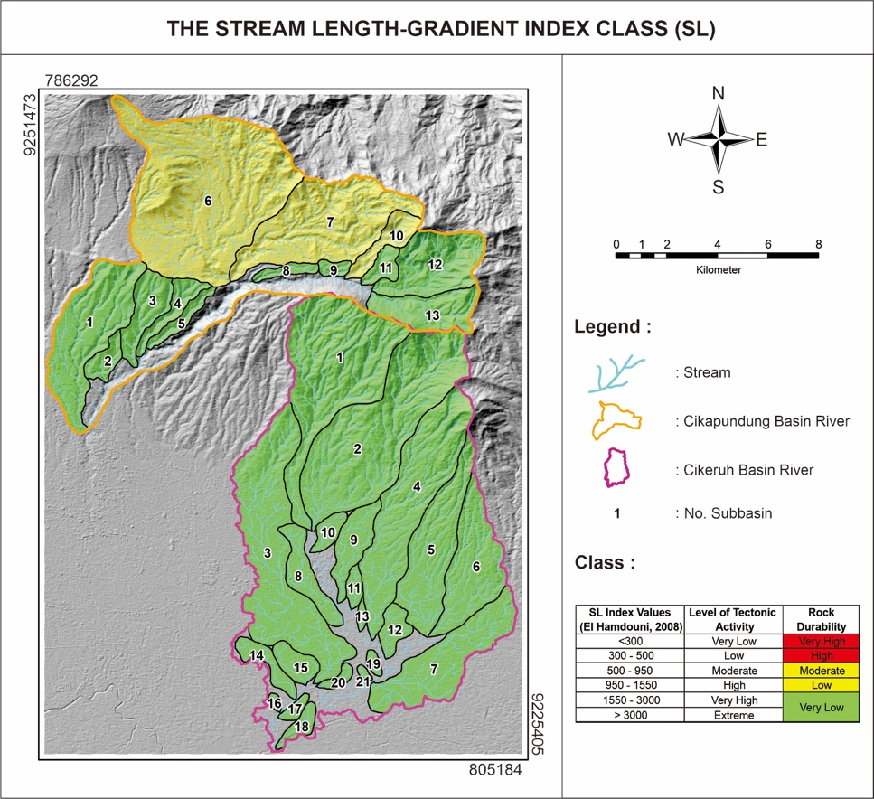
Figure 7. Map of SL calculations in the research area

Based on the information provided, it becomes evident that the sub-watersheds located in the Cikapundung and Cikeruh upstream exhibit stream length gradient values ranging from low to medium. These values are associated with volcanic rocks found in an area affected by active tectonic activity along the eastern section of the Lembang fault. This pattern is consistent with watersheds in the central to northern parts of Java, where tectonic activity is prominent. Conversely, the western portion of the region is unaffected by tectonic influences. These observations suggest the presence of tectonic processes, including the existence of faults in the watershed.

In the case of watershed 27, it is noteworthy that despite the absence of apparent faults in the vicinity, the rocks present in this area display lower resistance, resulting in an increase in stream length gradient values. This phenomenon may be attributed to the potential presence of concealed faults or other external processes that are notably intense and rapid, such as landslides or vertical erosion. Watersheds falling within this category share relatively homogeneous lithological characteristics with those in classes 2 and 3, highlighting that lithology is not the primary influencing factor, but rather, it is the presence of active tectonic processes that plays a pivotal role.

- Relative Active Tectonics Index (IATR)

The method of assessing relative active tectonic index as outlined by El Hamdouni et al. (2008), involves the classes of tectonic classes based on specific parameters, including SL, Vf, Hi, Bs, AF, and Smf. In this research, tectonic class division is performed using three key parameters: the sinuosity of mountain front (Smf), the valley floor width to valley height ratio (Vf), and the asymmetry factors (Af). These parameters are used to classify tectonic activity into three tectonic classes: class 1, class 2, and class 3.

Table 1. Classification of relative active tectonic index using morphotectonic parameters (El Hamdouni, 2008).
No | Morphotectonic Parameters | Classification of Tectonic Activity
 |  | Class 2 | Class 3 | Class 4
1 | BS | (Bs ≥ 4) | (3 ≤ Bs ≤ 4) | (Bs ≤ 3)
2 | AF | (Af ≥ 65) atau (Af < 35) | (35 ≤ Af < 43) atau (57 ≤ Af < 65) | (43 ≤ Af < 57)
3 | Vf | (Vf ≤ 0.5) | (0.5 ≤ Vf < 1.0) | ( Vf ≥ 1)
4 | SMF | (Smf < 1.1) | (1.1 ≤ Smf < 1.5) | (Smf ≥ 1.5)

Determination of the IATR carried out by taking the average values of all morphotectonic parameters in each sub-watershed. Furthermore, the division of tectonic classes is carried out based on IATR values which refer to El Hamdouni et al. (2008):
- Very high tectonic activity class/class 1 (1 ≤ IATR < 1.5)
- High tectonic activity class/class 2 (1.5 ≤ IATR < 2)
- Medium tectonic activity class/class 3 (2 ≤ IATR < 2.5)
- Low tectonic activity class/class 4 (IATR ≥ 2.5)

The results of the IATR analysis in the research area are divided into 4 classes, namely:
- Class 1 is found in only 1 (one) Cikeruh watershed, namely sub-watershed 1 in the central part of the research area, with an IATR value of 1,8 with a percentage of 34.49% of the research area.
- Class 2 is found in only 2 (two) Cikapundung sub-watershed 2 and and Cikeruh Sub-watershed 5, located in the central part of the research area, with an IATR value of 1.8 with a percentage of 34.49% of the area of the research area.
- Class 3 is found in 11 (eleven) sub-watershed including; The Cikapundung watershed is in sub-watersheds (1,4,8,10) in the western, southeastern, central and northern parts and the Cikeruh sub-watershed (4,5,12,9,10,15,17) is in the eastern to southeast, west to south of the research area, with a value range of 2.20-2.40 which is the moderate tectonic activity class, covering 22.92% of the research area.
- Class 4 is found in 20 (twenty) sub-watersheds including; the Cikapundung watershed is in sub-watersheds (2,3,6,7,8,11,12,13). While the Cikeruh watershed is in sub-watersheds (3,6,7,8,11,13,14,16,18,20, 21) are in the north, east, south and northwest of the research area, with a value range of 2.60-3.00 which is a class of low tectonic activity, covering a percentage of 45.59% of the area of the research area.

Based on this analysis, the research area is generally affected by low tectonic activity (class 4). The results of this analysis can be used as a reference in determining tectonic activity in the research area. There are segments of the Lembang fault that are in the eastern part, the more towards the east the weaker the activity of the Lembang fault is because the main source is in the middle which can be reflected in the results of morphotectonic calculations and morphological formations in the field. From the morphology that developed in the area, not only from the morphology but from the lithology affecting the results of morphotectonic calculations in the research area (Figure 8).

Relative active tectonic index based on geomorphic indications tends to only focus on evaluations of foreland mountains or areas (Arisco et al., 2006). This class of relative active tectonic index evaluates tectonics over a wider area using several geomorphological parameters. The average values of the measured geomorphological parameters (HI, AF, BS, VF and SL) were used to evaluate the distribution of relative active tectonic in the research area (El Hamdouni et al., 2007).

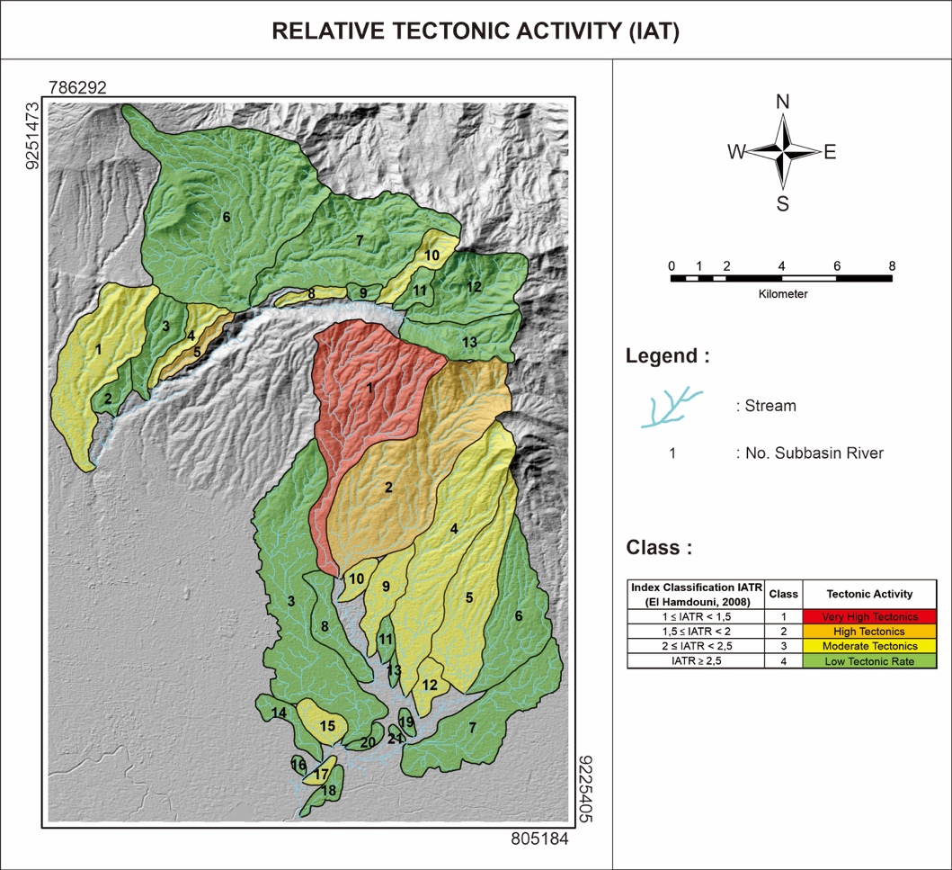

Figure 8. IAT distribution map in the research area

DISCUSSION
Morphotectonic calculations conducted in the Cikapundung and Cikeruh watersheds indicate that, on average, the sub-watersheds exhibit a moderate to low level of tectonic activity. The assessments of the valley floor width to valley height ratio (Vf) predominantly fall into the second category, which corresponds to valleys displaying moderate uplift. Most of the valleys with smaller Vf values are situated within the regions characterized by old volcanic products that have undergone erosion (Qvu) and young volcanic areas that remain largely unaffected by erosion (Qyu). These areas are associated with medium rock resistance, leading to the formation of V-shaped valleys. Conversely, the valleys with larger Vf values are primarily distributed across sand tuff (Qyd) and pumice tuff (Qyt) units, which possess lower rock resistance, resulting in valleys that tend to exhibit a U-shaped configuration.

The results of the asymmetry factors (AF) calculation show that most of the sub-watersheds are classified as gently asymmetric basins with tectonic classes spread from active to low tectonic classes. The calculation of the basin shape index (Bs) shows that most of the sub-watersheds have a rounded shape, which indicates that tectonic activity has slowed down or stopped and is included in the low tectonic class. Calculation of the stream length gradient index (SL) shows that most of the sub-watersheds belong to the low tectonic class. Morphotectonic characteristics the sub-watershed has an average of moderate to low tectonic class because the lithological response influences the analysis results which are composed of old, undecomposed volcanic product units (Qvu) which are rocks with medium resistance and units of pumice tuff (Qyt) and sand tuff. (Qyd) which has lower rock resistance resulting in erosion processes.

The results of all morphometric analyses indicate that a section of the eastern Lembang fault exhibits varying degrees of tectonic activity. In this context, one segment of the fault displays high, moderate, and low levels of tectonic activity. This segmentation highlights the potential occurrence of frequent tectonic movements, which may be indicative of seismic activity such as earthquakes. The fault segments with the highest tectonic activity are situated in the vicinity of the central Lembang fault zone, where it intersects with rock formations consisting of Quaternary volcanic rocks denoted as Qvu and Qyu. Conversely, the eastern Lembang fault intersects with Omtl and Omtu rock formations comprised of breccias, sandstones, and shales, which have a high tectonic age. Although the eastern Lembang fault is located within Quaternary-aged formations, morphological evidence suggests that it experienced considerable tectonic activity.

The field-based morphological observations primarily align with the findings from morphometric analysis. These observations are concentrated in regions exhibiting relatively high to high levels of tectonic activity. The significance of these morphological observations lies in their contribution to the analysis of active tectonics or neotectonics, as deformations become more apparent through the manifestation of morphological features. These field-based morphological features include linear valleys, meandering watershed courses, abrupt escarpments, occurrences of landslides, the presence of alluvial materials intersected by faults, and the emergence of springs (as depicted in Figures 9, 10, and 11).

The existence of these natural formations, coupled with the outcomes of morphometric analysis, provides evidence for the presence of active tectonic activity, in accordance with the model proposed by Davis in 1984 (as cited in Haryanto, 1999). This model elucidates the morphological formations that can arise due to thrust fault and strike-slip fault structures occurring simultaneously, including features such as linear valleys, piedmont junctions, and triangular facets.

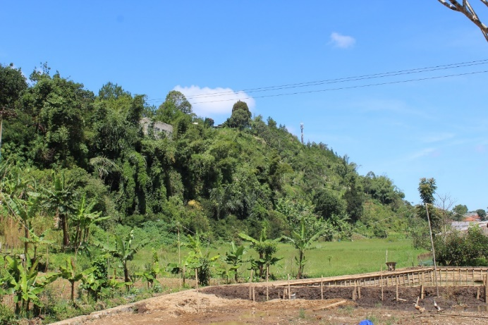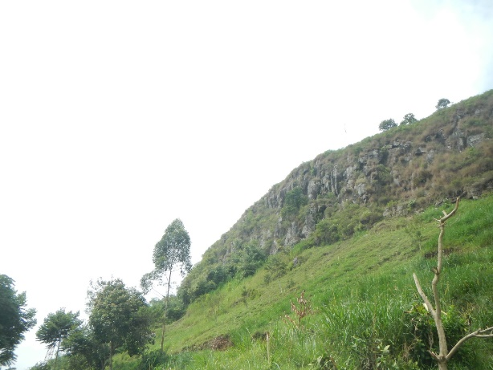
Figure 9. Fault scarp Lembang at Cikapundung, central section of the Lembang fault

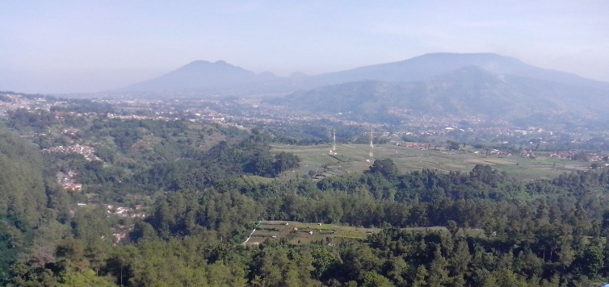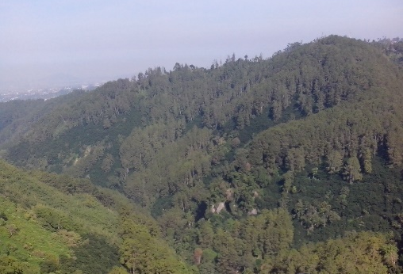
Figure 10. Linear fault valley at the Cikapundung research area in the middle part of the Lembang fault

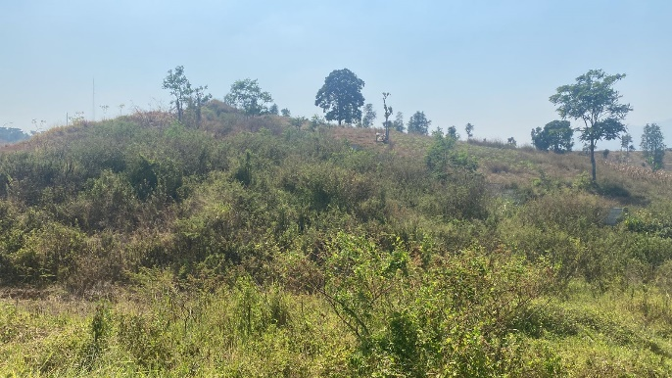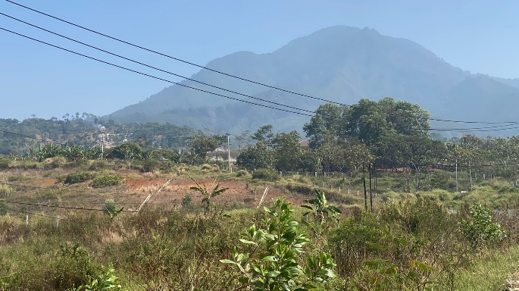
Figure 11. Lineament and fault scarp of the eastern part of the Lembang fault area Cikeruh

CONCLUSION
The results of the ridge straightness analysis show a dominant orientation in the north-south and north-east-southwest directions. It is suspected that this alignment is still affected by the existence of the Lembang fault. The research area includes two watersheds, namely the Cikapundung watershed and the Cikeruh watershed, which includes a total of 34 sub-watersheds. Calculations carried out to determine the Relative Active Tectonics Index (IATR) class 1 is found in only 1 (one) Cikeruh watershed, namely sub-watershed 1, class 2 is found in only 2 (two) Cikapundung sub-watershed 2 and and Cikeruh sub -watershed 5, class 3 is found in 11 (eleven) sub-watershed including; the Cikapundung watershed is in sub-watersheds (1,4,8,10), class 4 is found in 20 (twenty) sub-watersheds including; the Cikapundung watershed is in sub-watersheds (2,3,6,7,8,11,12,13). Highly active and active tectonic classes are mainly concentrated in the central region of the research. The moderate tectonic class extends from the central to northeastern regions, and is found in the western part, while the low tectonic class is more common in the western region.
Morphometric analysis shows that most of the eastern Lembang faults show varying levels of tectonic activity. Specifically, these fault segments show high, medium, and low levels of tectonic activity. This segmentation indicates the possibility of repeated tectonic movements, which can be an indicator of seismic and landslide events in the region. The results of morphological observations in the field are closely related to the results of morphometric analysis. These field observations are concentrated in areas that have high to low levels of tectonic activity. Examination of this morphology is especially important in the research of active tectonics or neotectonics, as it allows a clearer picture of the effects of visible deformation on morphological features.
Morphological characteristics found during field research include linear valleys, meandering watershed flows, fault slopes, landslide events, the presence of alluvial material that intersects with faults. The existence of these natural formations, in addition to the results of morphometric analysis, provides strong evidence of active tectonic activity, in line with models that describe the formation of thrust and strike-slip fault structures simultaneously. This model explains the potential for morphological formations due to thrust and strike-slip faults, such as linear valleys, piedmont joints and triangular facets.
ACKNOWLEDGEMENTS
The author wishes to extend their appreciation for the assistance and support received during this research, particularly from the Academic Leadership Grant (ALG) Prof. Dr. Ir. Nana Sulaksana, MSP. in the Padjadjaran University and Geomorphology and Remote Sensing Laboratory at the Faculty of Geological Engineering, Padjadjaran University, which played an integral role in this research. Additionally, the author would like to express gratitude to friends who contributed to and backed this research endeavor. Hopefully, this activity can be useful for the broader community.
REFERENCES
- Arisco. G., Arnone, G., Favara, R., Nigro, F., Perricone, M., Renda, P., and Mondello, C., 2006. Integrated Neotectonics and Morphometrics Analysis of Northern Sicilly. Boll. Soc, Geol, It., 125, 15p.
- Bull, W. B., 2007. Tectonic Geomorphology of Mountains: A New Approach to Seismology. Blackwell, Malden.
- Dehbozorgi, M., Poukermani, M., Arian, M., Matkan, A.A., Motamedi, H., and Hosseiniasi, A., 2010. Quantitative Analysis of Relative Tectonic Activity in The Sarvestan Area, Central Zagros, Iran. Geomorphology 03284, 13p.
- El Hamdouni, R., Irigaray, C., Fernandez, T., Chacón, J., and Keller, E.A., 2007. Assessment of Relative Active Tectonics, Southwest Border of Sierra Nevada (Southern Spain). Geomorphology, 96, 150-173.
- Gentana, D., Sulaksana, N., Sukiyah, E., and Yuningsih, E. T. 2018. Index of active tectonic assessment: quantitative-based geomorphometric and morphotectonic analysis at Way belu drainage basin, Lampung Province, Indonesia. International Journal of Advanced Science Engineering Information Technology, 8(6), 2460-2471.
- Hamilton, R., 1979. Tectonics of Indonesia Region. Geological Survey Professional Paper 1078, 345 p
- Haryanto, I., 1999. Tektonik Sesar Baribis, Daerah Majalengka, Jawa Barat. Tesis Magister. Bandung: Institut Teknologi Bandung.
- Haryanto, I., 2006. Struktur Geologi Paleogen dan Neogen Di Jawa Barat. Bulletin of Scientific Contribution: Geology, 4(1): 88-95.
- Hidayat, E., 2009. Analisis Morfotektonik Sesar Lembang; Thesis Master. Bandung: Institut Teknologi Bandung.
- Huggett, R., 2011. Fundamentals of geomorphology. Routledge.
- Keller, E. A. and Pinter N. 1996. Active Tectonics (Earthquake, Uplift and Landscape). Upper Saddle River, New Jersey: Prentise Hall.
- Ramirez-Herrera, M. T., 1998. Geomorphic Assesment of Active Tectonics in The Acambay Graben, Mexican Volcanic Belt. Earth Surface Processes and Landforms, 23, 317-332.Silitonga, P. H. 1973. Peta Geologi Lembar Bandung, Jawa, skala 1:100.000. Bandung: Pusat Penelitian dan Pengembangan Geologi.
- Rendra, P. P. R., Sulaksana, N., and Sulastri, M. 2021. Drainage Pattern Characteristics of Jatinangor Area, Sumedang Regency, West Java. Remote sensing, 5, 6.
- Stewart, I.S., dan Hancock, P.L., 1994. Continental Deformation in Neotectonic. Pergamon Press.
- Sulaksana, N., Supriyadi, I., Rendra, P. P. R., and Sulastri, M. 2017. Active fault analysis through quantitative assesment method in Cikapundung Sub Watershed. International Journal of Scientific Research in Science and Technology, 3(6).
- Supartoyo, dan Surono, 2008. Katalog Gempabumi Merusak Indonesia Tahun 1629 - 2007, Pusat Vulkanologi dan Mitigasi Bencana Geologi, Badan Geologi, Departemen Energi dan Sumber Daya Mineral: 101 hal.
- Van Bemmelen, R. W., 1949. The Geology of Indonesia, Vol. IA. The Haque, Martinus, Nijhoff.

